RFID BASED ON ATTENDENCE SYSTEM

Presented by:

Bailadugu Bhuvaneswari --22491A0470
Vadlamudi Vanaja --22491A04W3
Kanagala Poojitha --22491A04L3
Vengala srinivasula Reddy --22491A04C9
Suddikattu Vamsi --22491A04I7
Perikala Karthik --22491A0442

ABSTRACT :
Integrates RFID and Face Recognition for precise and automated attendance tracking.Utilizes face recognition algorithms to capture live images of individuals.Features dual authentication with the addition of RFID functionality.Effectively prevents false attendance and misuse of time.Provides an easy-to-use system for efficient tracking and logging.Scalable to accommodate a large number of users.Enhances time management and promotes accountability.Simple to install and convenient to store.

INTRODUCTION:
Smart attendance systems have revolutionized attendance tracking by integrating face recognition with RFID technology. Each individual is equipped with a portable RFID tag, allowing seamless coverage without requiring a direct line of sight. When the individual enters a restricted area, such as a classroom or office, an electromagnetic sensor detects the tag, triggering the system to capture an image. This image is then compared with stored facial data in the database to verify the identity of the individual.
Once the system successfully verifies the identity, the individual's attendance is automatically recorded. This dual-verification method, combining RFID and facial recognition, eliminates issues such as proxy attendance and fraud. It streamlines roll calls and attendance processes, reducing the administrative burden for school administrators.
Highly adaptable, this system can be implemented across various applications, including educational institutions, corporate offices, factories, and other organizations. It enhances accountability, punctuality, and reliability in attendance management. Additionally, it provides administrators with an efficient way to track, monitor, and generate attendance reports, leading to improved operational efficiency.
.
KEYWORDS:
- Smart Attendance System
- RFID Technology
- Face Recognition
- Dual Verification
- Attendance Tracking
- Automatic Recording
- Proxy Attendance Prevention
- Database Verification
- Adaptable Applications

LITERATURE SURVEY :

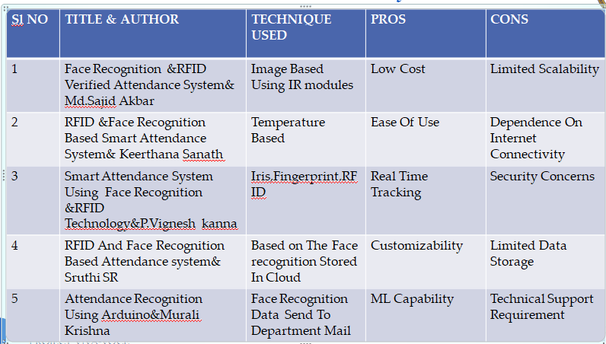
Functional Layout:
* A smart attendance system that uses face and RFID data can automatically record student entry and exit times, and keep a record of attendance
* The system can help to prevent cheating and proxy attendance, and can also help to ensure that students are properly registered and accounted for

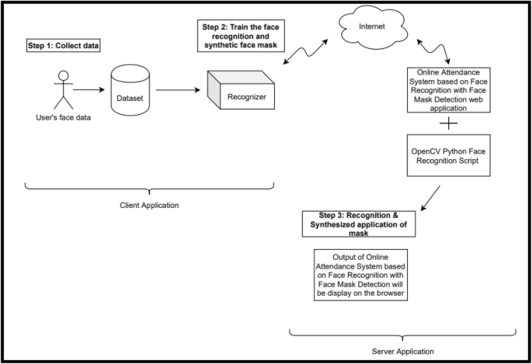
.

Methodology :

System Components:RFID Reader: Scans RFID tags attached to student ID cards.Camera: Captures images of students' faces.Microcontroller/Processor: Processes data from the RFID reader and camera.Database: Stores student information, attendance records, and face templates.Software: Implements face recognition algorithms, database management, and user interface.
System Workflow:Student Registration:RFID Tag Assignment: Assign a unique RFID tag to each student.Face Data Collection: Capture multiple images of each student's face from different angles and lighting conditions.Face Template Creation: Process the captured images to create face templates using a suitable face recognition algorithm (e.g., Eigenfaces, Fisherfaces, or Deep Learning-based methods).
RFID Tag Scan: When a student approaches the attendance system, the RFID reader scans their ID card, capturing the RFID tag ID.Face Capture: The camera captures a live image of the student's face
.Face Recognition: The captured image is compared with the stored face templates in the database using the chosen face recognition algorithm.Attendance Verification: If the face is recognized with a high degree of confidence, the system verifies the RFID tag ID with the database entry.
Security Considerations:Data Privacy: Implement robust security measures to protect student data, including encryption and access controls.Face Template Quality: Ensure high-quality face templates to improve recognition accuracy.Tamper Prevention: Protect the system from unauthorized access and tampering.Error Handling: Implement error handling mechanisms to address issues like incorrect RFID scans or failed face recognition

Blockdiagram :

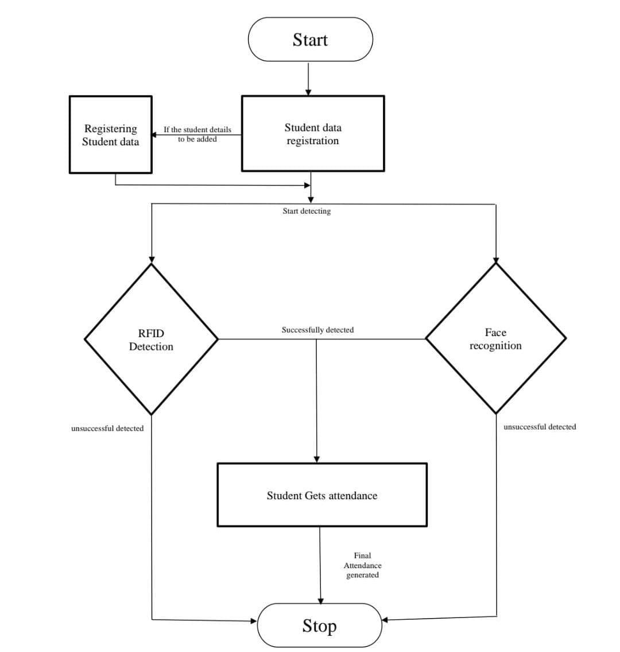

Applications :
• Educational Institutions
- Schools, colleges, and universities for student and staff attendance tracking.
• Corporate Offices
- Employee attendance monitoring and access control.

• Factories and Manufacturing Units
- Workforce management and tracking in industrial environments.
• Healthcare Facilities
- Attendance tracking for medical staff and ensuring authorized access to restricted areas
Conclusion :

The RFID-based attendance system integrated with face recognition offers a reliable, secure, and automated solution for attendance tracking. By combining RFID technology with facial biometrics, the system minimizes errors, reduces the risk of fraud, and ensures seamless operation. Its user-friendly design and centralized database make it ideal for institutions and organizations seeking efficient management of attendance records..

REFERENCE:
- Narayan Vyas, Chandigarh University, “RFID Based Attendance Monitoring System Using ESP8266 Wi-Fi Module and IoT Enabled Mobile Application”, Article in Neuro Quantolog September 2022 DOI: 10.14704/nq.2022.20.9. NQ44681
- Hitesh Walia, Neelu Jain, “Fingerprint Based Attendance System Using Lab VIEW and GSM”, International Journal of Innovative Research in Science, Engineering and Technology, 5 (7), July 2016, ISSN: 2319- 8753
- Lim,T.S., Sim,S.C. &Mansor,M.M.(October 4-6, 2009), ―RFID Based Attendance System‖ 2009 IEEE Symposium on Industrial Electronics and Applications (ISIEA 2009), Kuala Lumpur, Malaysia.

